**Quantitative Results from User Study**

|  |  |  |  |  |  |  |  |  |  |  |  |  |  |  |  |  |  |  |  |
| --- | --- | --- | --- | --- | --- | --- | --- | --- | --- | --- | --- | --- | --- | --- | --- | --- | --- | --- | --- |
|  | | | | | **Setting Goals** | | | | **Feedback** | | | | **Self-Monitoring** | | | | **Effectiveness** | | |
| **Student** | **Age** | **Degree Leve** | **Course** | **Goals** | **Q1** | **Q2** | **Q3** | **Q4** | **Q1** | **Q2** | **Q3** | **Q4** | **Q1** | **Q2** | **Q3** | **Q4** | **Q1** | **Q2** | **Q3** |
| *Student 1* | 23 | Masters | Architecture |  | 4 | 2 | 3 | 2 | 3 | 5 | 4 | 3 | 4 | 3 | 3 | 3 | 4 | 2 | 3 |
| *Student 2* | 22 | Final (Undergrad) | History |  | 3 | 5 | 4 | 4 | 2 | 4 | 3 | 3 | 4 | 5 | 3 | 3 | 4 | 2 | 4 |
| *Student 3* | 20 | Second Year | History |  | 4 | 3 | 4 | 4 | 3 | 5 | 4 | 4 | 3 | 3 | 4 | 3 | 4 | 3 | 3 |
| *Student 4* | 23 | Masters | Comp Sci |  | 2 | 2 | 2 | 2 | 2 | 1 | 1 | 1 | 4 | 5 | 3 | 2 | 3 | 2 | 2 |
| *Student 5* | 22 | Final (Undergrad) | Media |  | 3 | 4 | 4 | 5 | 3 | 4 | 4 | 4 | 3 | 4 | 4 | 4 | 5 | 4 | 4 |
| *Student 6* | 23 | Masters | Maths |  | NA | NA | NA | NA | 4 | 4 | 4 | 4 | 4 | 5 | 4 | 4 | 4 | 4 | 4 |
| *Student 7* | 23 | Final (Undergrad) | Marketing |  | NA | NA | NA | NA | 5 | 4 | 5 | 5 | 4 | 5 | 4 | 5 | 4 | 5 | 5 |
| *Student 8* | 23 | Final (Undergrad) | Business |  | NA | NA | NA | NA | 3 | 3 | 2 | 3 | 4 | 3 | 3 | 4 | 3 | 3 | 3 |
| *Student 9* | 22 | PhD | Politics |  | NA | NA | NA | NA | 3 | 2 | 2 | 3 | 3 | 1 | 2 | 2 | 1 | 1 | 1 |
| *Student 10* | 23 | Final (Undergrad) | Graphics |  | NA | NA | NA | NA | 4 | 5 | 5 | 5 | 3 | 3 | 3 | 3 | 4 | 5 | 5 |

**Changes in Sugar Consumption**

|  |  |  |  |  |  |
| --- | --- | --- | --- | --- | --- |
| **Student** | **Before using the app** | **After using the app** | **Avg. for Week** | **Diff (Before and Avg.)** | **Difference**  **(After and Avg.** |
| *Student 1* | 115.64g | 58.09g | 52.18g | -55.53 | 5.901 |
| *Student 2* | 45.58g | 17g | 70.42g | 21.73 | -53.42 |
| *Student 3* | 70.79g | 45.93g | 60.61g | -8.90 | -14.68 |
| *Student 4* | 23.89g | 17.12g | 33.54g | 8.44 | -16.42 |
| *Student 5* | 20.39g | 19.7g | 38.94g | 16.23 | -19.24 |
| *Student 6* | 86.94g | 36.9g | 58.08g | -25.25 | -21.18 |
| *Student 7* | 82g | 77.14g | 79.75g | -1.97 | -2.61 |
| *Student 8* | 68.37g | 65.42g | 67.53g | -0.74 | -2.11 |
| *Student 9* | 60.89g | 35.44g | 42.41g | -16.17 | -6.97 |
| *Student 10* | 50.62g | 33.21g | 53.99g | 2.97 | -20.78 |

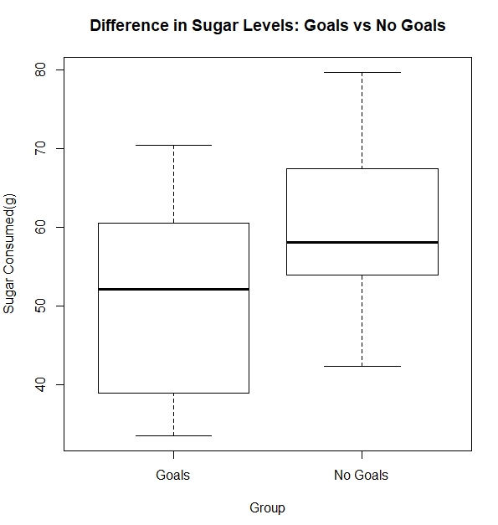

**Regression Analysis Results**

|  |  |  |  |  |
| --- | --- | --- | --- | --- |
| **Feedback and Monitoring** | | | | |
|  | Estimate | Std. Error | t value | Sig. |
| (Intercept) | -1.7345 | 0.9336 | -1.858 | 0.10556 |
| Feedback | 0.6444 | 0.1701 | 3.787 | 0.00683 |
| Monitoring | 0.8282 | 0.2669 | 3.103 | 0.01726 |
| **Goals** | | | | |
|  | Estimate | Std. Error | t value | Sig. |
| (Intercept) | 0.9974 | 0.8431 | 1.183 | 0.3220 |
| Goals | 0.6877 | 0.2484 | 2.769 | 0.0696 |

**Validity of Regression Analysis**

|  |  |  |  |
| --- | --- | --- | --- |
| **Analysis** | **Standard Error** | **R-Squared** | **Adjusted R-Squared** |
| Feedback and Monitoring | 0.5227 | 83.59% | 78.91% |
| Goals | 0.4425 | 71.88% | 62.5% |